Position: | Activations Executive
Division: | Activations
Department: | Sales, Commercial & Marketing
Reporting to | Manager - Activations
Employment Type | Permanent

Key Relationships | Internal  General Manager - Sales, Commercial and Marketing  Manager - Activations  Business Development Manager  Business Development Executives/s  Activations Executive/s  All Staff  Other internal stakeholders as relevant and appropriate  External  Key event Partners, sponsors, suppliers and clients  Promotional Agencies as relevant to role  Contemporaries/Peers within the event space  Key international stakeholders i.e. Formula One Management and Dorna  Other stakeholders as required/relevant  Key suppliers and commercial partners  Other stakeholders as relevant and appropriate

Values | Knowledge of and consistent demonstration of the Corporation’s IIQCAT values: Integrity, Innovation, Quality, Customer, Accountability, Teamwork.  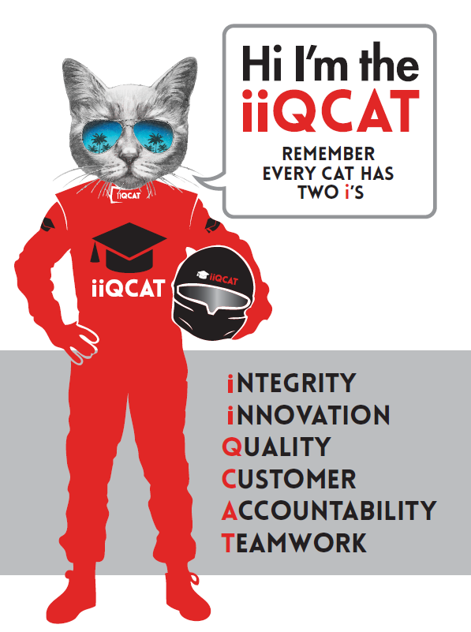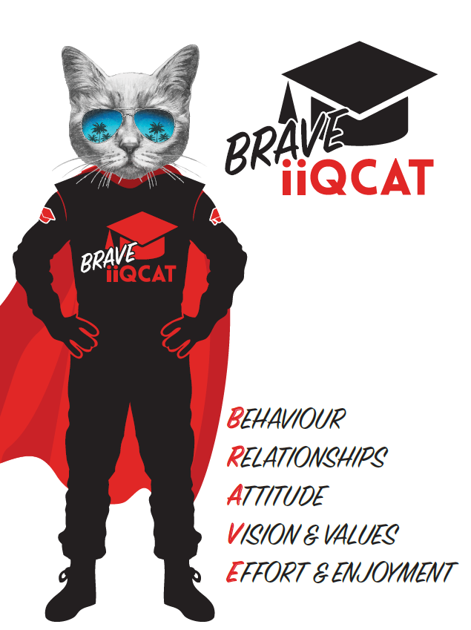
Corporation Objectives | To promote Melbourne and Victoria via the staging of two international sporting events - the Formula 1 Australian Grand Prix at Albert Park and the Australian MotoGP at Phillip Island.
Governed by | The Corporation is governed by the Australian Grands Prix Act 1994 (Vic).
Standards of behaviour | The Code of Conduct for Victorian Public Sector Employees governs the behaviour of all Corporation employees.
Human Rights | The Charter of Human Rights and Responsibilities Act 2006 is a Victorian law that sets out the basic rights, freedoms and responsibilities of all people in Victoria. The Charter requires the Corporation to act compatibly with human rights, and to consider human rights when developing policies, making laws, delivering services and making decisions.

Role Objectives | This role is responsible for the activation and servicing of  client accounts, and encompasses all AGPC assets and  partnership opportunities, from corporate hospitality  products to sponsorship activations.  This role manages an allocated portfolio of clients, to ensure that they receive the highest level of service and engagement in the delivery of contracted services. In doing so, this function plays a vital role in influencing client retention and resigning behaviours, and the function is incentivised on this basis.  The role focuses on the following areas of activity:  - Delivery of sponsorship contractual rights and benefits  - Delivery of corporate hospitality  - Build and fit-out of private corporate hospitality  - Relationship/account management of sponsors and corporate clients  - Development of legal briefs for sponsor contracts  - Assisting Business Development team with proposals/quotations  - Coordination of special events  - Coordination of debrief documents  - Facilitation of operational processes, i.e. safety and insurance, accreditation, signage, infrastructure ordering and planning, invoicing and other related administrative tasks  In undertaking these functions, this role is part of a wider team which is expected to act as ambassadors for the Corporation, its events and products; and in doing so to set the benchmark in terms of aligning with the organisations values (IIQCAT).
Core Responsibilities | Undertaking the required elements of the role, in a way that aligns with the view to quality work practices, including but not limited to assisting and managing the sales and commercial team:  - Work proactively with the Business Development Team to transition signed clients/partners, as seamlessly and professionally as possible.  - Engage in proactive and customer-focussed relationship management to promote long term engagement/retention and maximisation of revenue potential.  - Work collaboratively with both the Activations and Business Development team, to ensure  accurate, timely and professional scoping, planning and delivery of client requirements.  - Play an active role in delivery of event time client requirements.  - Undertake all housekeeping and administrative tasks required to maintain account management tools, systems and resources (e.g. EFD, CRM, TAF’s, Safety and Insurance, contract management).  SKILLS AND EXPERIENCE  - Experience within an event-based account management role  - Demonstrable skill and experience in managing sophisticated partnerships and activations  - Well-developed lateral thinking and problem solving skills  - Outstanding interpersonal, networking, communication and relationship management skills  - Demonstrable skills in time management, planning and strategic thinking, combined with strong commercial acumen  - Integrity, focus and emotional maturity, combined with the ability to self-motivate  - Superior organisation skills and attention to detail  - The ability to combine a systematic and logical approach with broader strategic thinking  - Knowledge of AGPC products and processes  - Immaculate and professional personal presentation  Team:  Provide support to members of the Sales and Commercial Team, to drive motivation, performance and achievement of outcomes.  All work to be done in alignment with AGPC values to ensure a cohesive, constructive and excellence-driven team culture.  Act as a role model for organisational standards, values and professionalism.  Other duties at the reasonable request of the Division Manager - Sales and Commercial, GM Sales, Commercial and Marketing or Chief Executive Officer.  At the reasonable request of your Division Manager; General Manager and/or the Chief Executive Officer, role responsibilities may be altered at any time. Changes will be tied to the Corporation’s strategic objectives, workforce planning and the structural alignment of the Corporation.  Governance  Adhere to Corporation policies, procedures, and directives regarding standards of workplace behaviour in completing job duties and assignments.  Conducting every aspect of work in a trustworthy, reliable and transparent manner, and maintaining the highest ethical standards.  Customer Service  Putting internal and external customers first, building strong relationships and ensuring that the approach is responsive to the needs of the internal/external customer.  Encouraging openness and trust by sharing information widely, listening, welcoming constructive challenge and encouraging free dialogue.  Continuous Improvement  Taking initiative to improve operations/services/products and systems so that they are consistent with the Corporation’s strategic direction and values; incorporating innovation and experimentation into daily work.  Health and Safety  To assist the Corporation in meeting its health and safety obligations you will be required to:  - Actively participate in the reporting of hazards, incidents and near misses.  - Take corrective action to address or mitigate any risks or hazardous situations throughout the course of your work.  - Take reasonable care for your own health and safety, and for the health and safety of others.  - Adhere to the Corporation’s various policies, procedures, work practices and standard operating procedures.  - Perform your role in accordance with any specific responsibilities as outlined in the Corporation’s safety management system.  To enable the Corporation to meet its obligations for providing a healthy and safe working environment for you, you must inform your manager of any issues which may impact your ability to safely perform your role.  Environmental Considerations  Cooperate with the Corporation regarding caring for the environment, by acting in a sustainable way and minimising environmental impact by adhering to the Corporation’s policies, procedures and work practices.

Person Specification

Qualifications and Experience | - Appropriate tertiary qualifications (degree, diploma or certificate) in sales, business, marketing or a related discipline  - Demonstrated relevant, equivalent professional experience of at least 3 years  - Knowledge and experience of account management in a fast-paced industry  - Proven ability to manage change in a complex work environment  - Highly developed interpersonal skills with the proven ability to build effective relationship and communicate with a diverse range of people both internal and external.

Relevant Traits and Characteristics | Customer Service  - Demonstrated achievement in and enthusiasm for the provision of quality customer service  - Immediately respond to customers’ needs or concerns to ensure the quality of service meets agreed standards  Teamwork, Adaptability and Resilience  - Demonstrated commitment to teamwork and the maintenance of a supportive work environment  - Ability to work effectively as part of a team in a fast-changing environment  - Keeping calm by demonstrating a capacity to positively deal with unanticipated problems and changing circumstances  Interpersonal, Verbal and Written Communication  - Well-developed written communication ability  - Strong interpersonal and communication skills  - An ability to liaise, negotiate and constructively provide and accept feedback from staff at all levels  Organisation and Planning  - Organisational and planning skills in managing a personal workload in a busy environment with conflicting demands  - Ability to meet deadlines  Technology  - Experience in the use of Microsoft desktop products such as Word, Excel, Outlook and PowerPoint  - Experience in information management systems, including internet and on-line environments  Continuous Learning and Professional Development  - Demonstrated commitment to continual professional and personal development

